Student Wellness Commission  Soz Mirza, Public Relations Director  Christina Lee, Commissioenr  uclaswc@gmail.com  310-825-7586 | 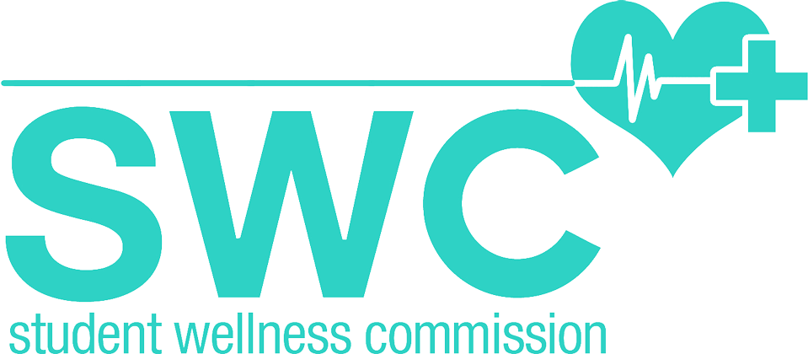

FOR IMMEDIATE RELEASE

UCLA’s Student Wellness Commission Launches Free Menstrual
Product Program in UCLA Ashe Student Health & Wellness Center
First public university to offer free menstrual products

UCLA –Feb. 20, 2017 – The Student Wellness Commission at UCLA recently introduced the first student initiated and student funded program at a public university, and the first university on the west coast to offer free menstrual hygiene products to all students.

Unlike drives that collect menstrual hygiene products such as pads and tampons from donations, this program is institutionalized in The Ashe Center and will continue to serve the student population. Students are able to safely and comfortably access pads and tampons alongside previously offered hygiene products, such as toothbrushes, and toothpaste, by the clinic desks and through more discreet dispensers located near the restrooms. The Student Wellness Commission not only looks to increase resources available at the school, but also hopes to address stigma surrounding menstrual cycles through the program.

The Student Wellness Commission seeks to be inclusive in this conversation regarding menstruation— women are not the sole consumers of such hygiene products. By offering these products by both the men’s and women's restrooms, in addition to the gender neutral restrooms, inclusivity is central to the conversation. The products are also accessible at UCLA’s LGBT Campus Resource Center.

<<insert quote here>>

Over the past 10 weeks, the Ashe Center has been able to track the consumption of these products and has estimated that over 1000 pads and tampons have since been distributed. Ashe Center interns continue to restock on a daily basis, to fulfill the high demand and necessity of these products. Students are limited to 3 products per visit.

The Ashe Center and Student Wellness Commission plans to survey the population within the next school year to assess further needs and adjust the available products as needed. Currently, $10000 have been allocated solely to fund this project.
The Student Wellness Commission hopes to expand the availability of these resources to different parts of campus in the future, including but not limited to the dorms.

The mission of the Student Wellness Commission is to promote the holistic health and wellness of the UCLA student body through programs, events, advocacy efforts, and health education. With 12 committees, SWC covers a wide range of important topics such as sexual health, physical wellness, and mental illness. Our programs range from health symposiums to Bruin Plaza fairs to an annual 5K race, and we proactively push for actionable change on this campus.

For more information about Student Wellness Commission, or to get involved, visit www.swc.ucla.edu.

To visit The Ashe Center website, visit www.studenthealth.ucla.edu.

# # #

http://dailybruin.com/2016/11/22/student-wellness-commission-begins-providing-free-menstrual-products/

http://dailybruin.com/2017/01/31/usac-expands-efforts-to-provide-free-feminine-hygiene-products/

